Q1.
Answer is C.

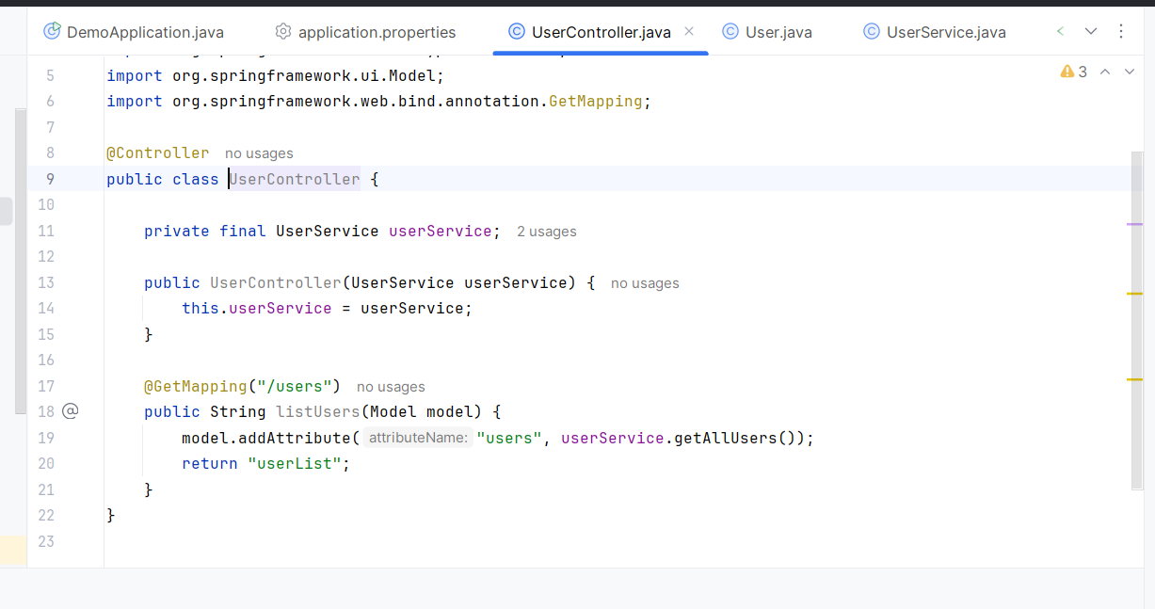

A: Incorrect. Uses HttpServletRequest to set the attribute directly.This will work, because the JSP or Thymeleaf view can access request attributes. Not recommended for clean Spring MVC design.

B: Also Correct . create object and Write both model and view in one object. It can be more coded.

C: Correct. Clean separation of concerns: Website → Controller → Service → View.

D: Incorrect. @RestController is a specialized @Controller that adds @ResponseBody to every method. This returns JSON data, not a view.

Q2
Answer is A.

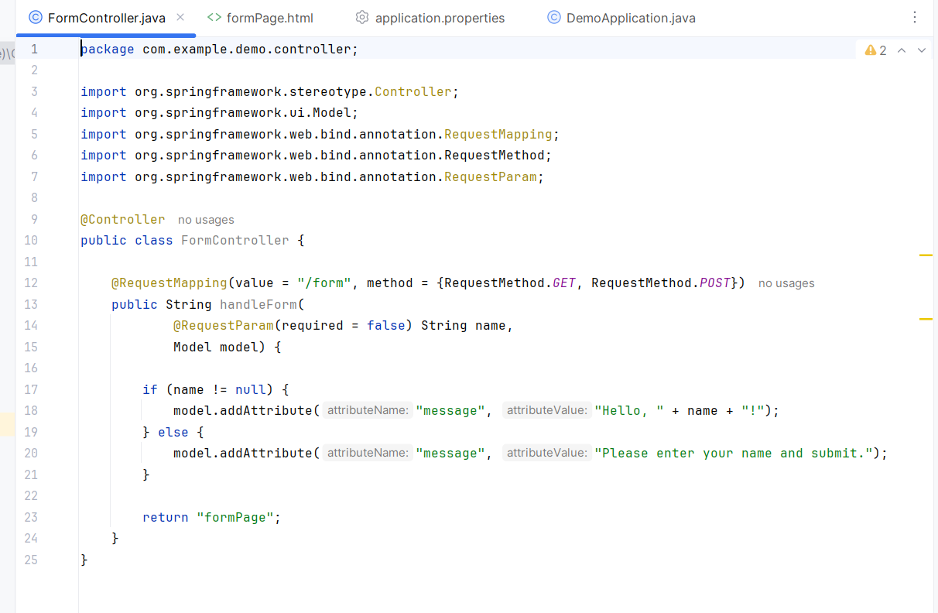

A: Correct.
@RequestMapping is the general-purpose annotation for mapping web requests to methods.
{RequestMethod.GET, RequestMethod.POST} → means this method will handle both GET and POST requests.

B: Incorrect. Cannot combine both on the same method.

C: Incorrect.@Controller does not accept a methods attribute.

D: Incorrect. RequestMethod.ALL does not exist in Spring MVC.

Q3.
Answer is C.

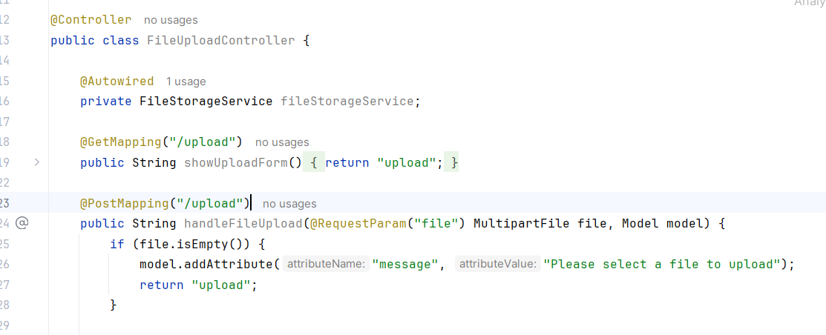

A: Incorrect. @RequestParam("file") String file tries to bind the uploaded file to a String.File is binary data not string type.

B: Incorrect. Reads raw request body; not standard for multipart forms.

C: Correct. MultipartFile is Spring’s standard abstraction for uploaded files.

D: Incorrect. More low-level and verbose compared to Spring’s MultipartFile. More step between upload file.

Q4.
Answer is B.

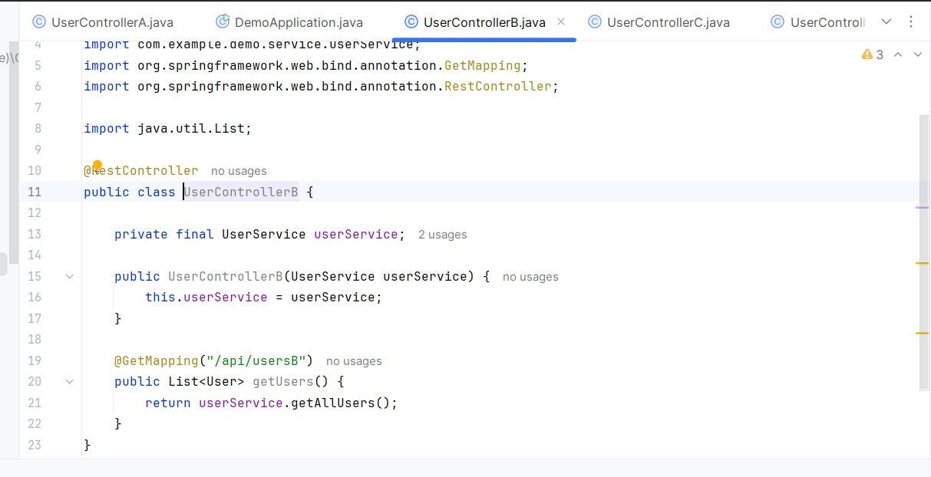

A: Incorrect.
@Controller without @ResponseBody returns a view name, not JSON.

B: Correct.
Returns JSON data automatically; combines @Controller + @ResponseBody.
List<User> return object converted to JSON by Spring.

C: Also correct.
@Controller combined with @ResponseBody returns JSON.

D: Incorrect.
Requires extra configuration (jsonView) for JSON.
@RestController automatically handles JSON conversion without extra view configuration.

Q5.
Answer is A.

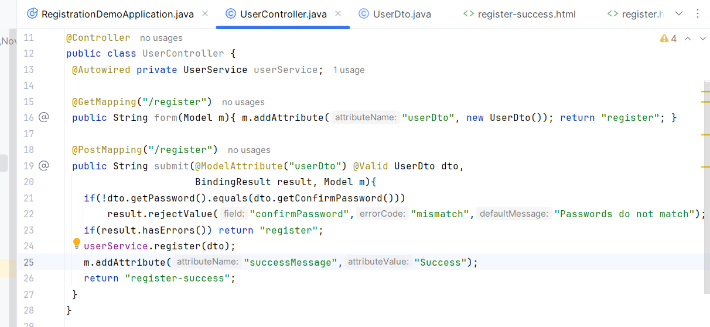

A: Correct.
Spring validates the User object using @Valid.
Validation errors, if any, are stored in BindingResult.

B: Incorrect.
@Validated is similar to @Valid.
Missing BindingResult, so validation errors cannot be easily checked and stored.

C: Incorrect. Manually calls a method user.isValid() inside the controller.

D: Incorrect. Cannot use Spring’s binding, type conversion, or validation annotations.

Q6.
Answer is

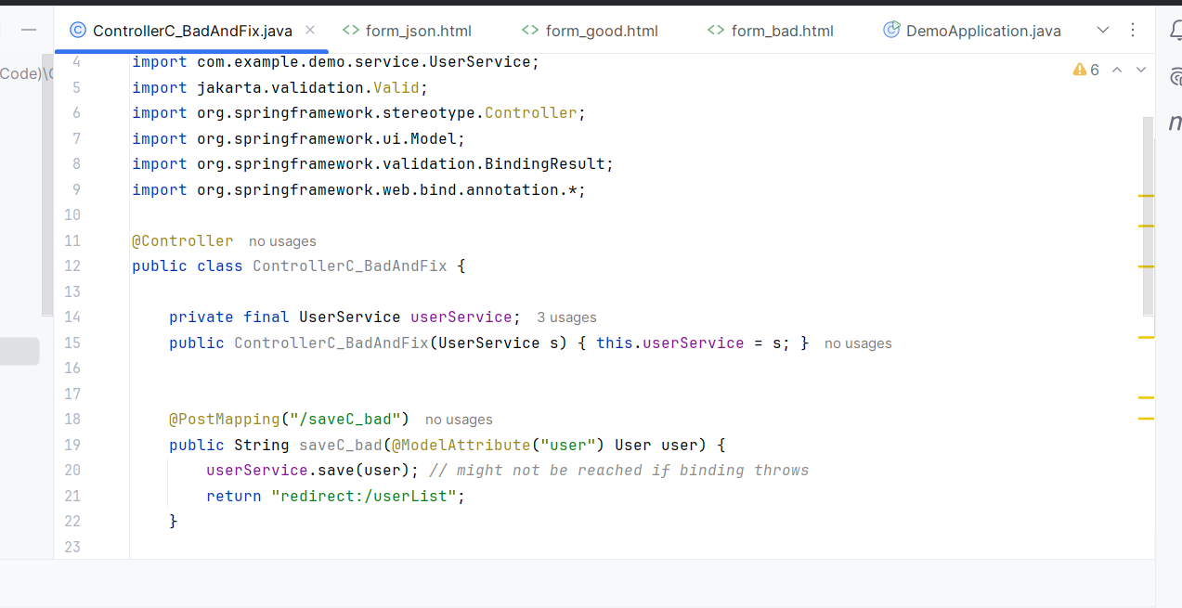

A: Incorrect.
@ModelAttribute bind request form data to a Java object and make that object available to the view.
@RequestBody maps the request body to a Java object.

B: Incorrect. Changing the return type does not prevent or resolve binding errors.

C: Correct. Missing required fields or validation constraints leading to binding/validation failures.A binding/conversion failure is exactly the sort of problem that produces 400 Bad Request in Spring MVC.

D: Incorrect. POST being used is not wrong.

Q7.
Answer is B.

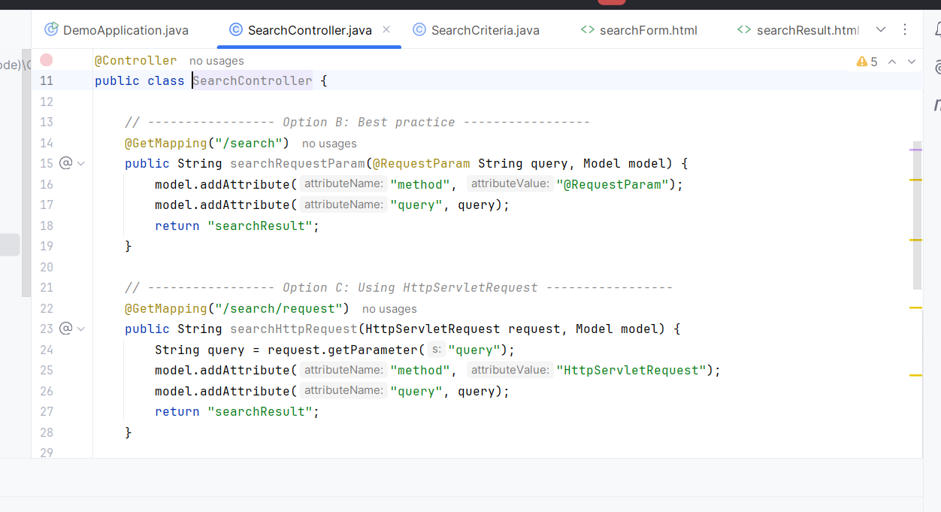

A: Incorrect. @PathVariable is used to extract values from the URI path, not query parameters.

B: Correct. @RequestParam is the standard way to bind query parameters . Directly maps query parameters from the request.

C: Correct.You can always access query parameters manually via HttpServletRequest.

D: Correct. @ModelAttribute binds all request parameters to a Java object. For multiple.

Q8.
Answer is A and B.

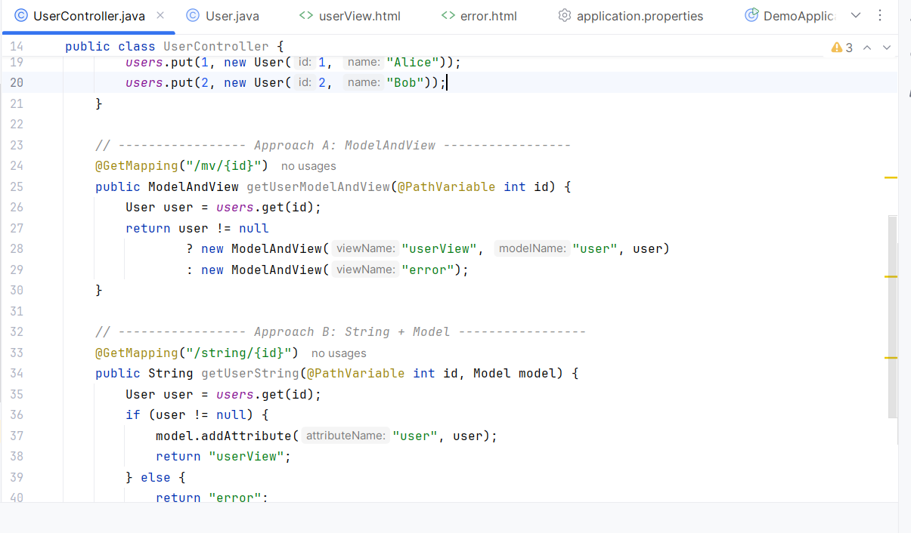

A: Correct.
ModelAndView used to conditionally render different views based on whether the requested user exists.
@PathVariable int id binds the {id} value from the URL path to the id parameter in the method.

B: Correct.
returning a String for the view name and using Model to pass attributes is the most common pattern.

C: Incorrect. Returning "userView" as a String here does not render the view template; it just sends "userView" as the HTTP response body.

D: Incorrect. write HTML directly is more difficult than testing standard view-returning methods.

Q9.
Answer is

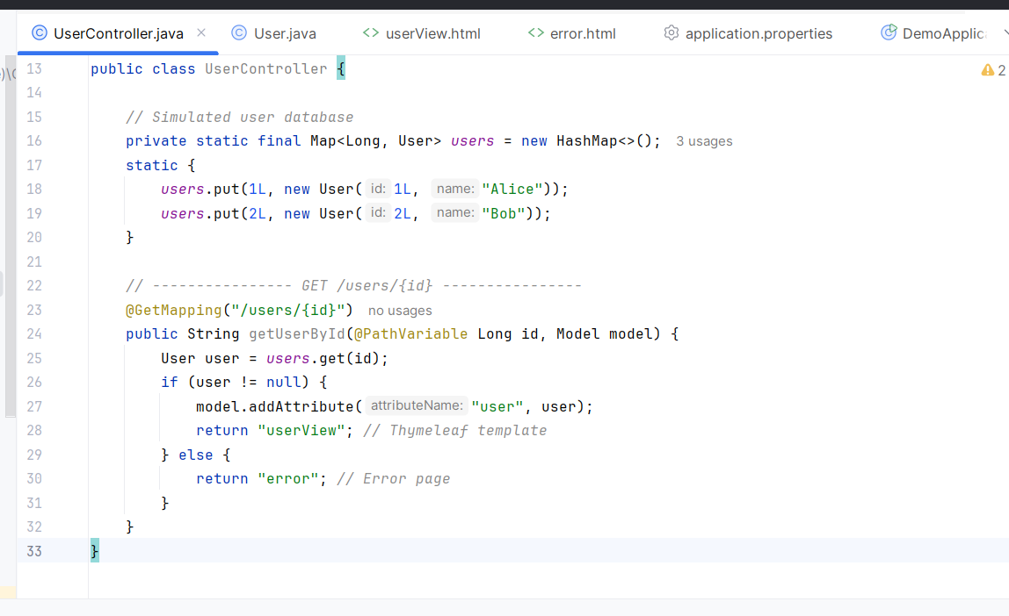

A: Incorrect. @RequestParam is used to extract query parameters from the URL, not path variables.

B: Correct. @PathVariable binds the path segment to a method. Example URL: /users/123 → id = 123

C: Incorrect. @PostMapping maps POST requests, not GET requests.

D: Incorrect. @RequestMapping is fine for GET requests, but here the parameter uses @RequestParam. /users/123 will not work, because 123 is in the path, not a query parameter.

Q10.
Answer is

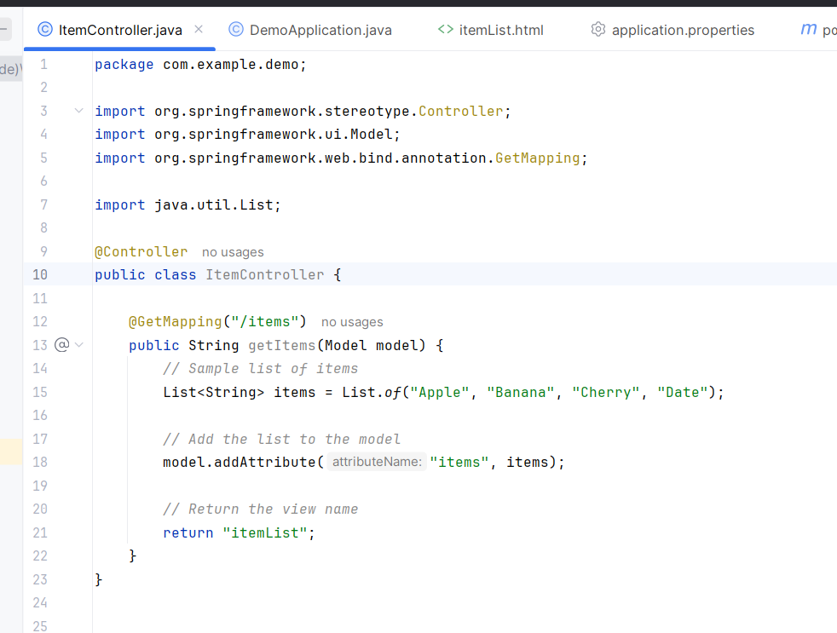

Website -- Controller -- Model -- View

A: Incorrect.
It cannot directly pass data to a view like JSP or Thymeleaf.

B: Incorrect.
Storing a list in the HTTP session across multiple requests.

C: Correct.
This is the standard Spring MVC approach.
The controller adds data to the Model.
And View come from model.

D: Incorrect.
@ResponseBody serializes the list to JSON for APIs. It is not meant for rendering traditional views.

Q11.
Answer is B.

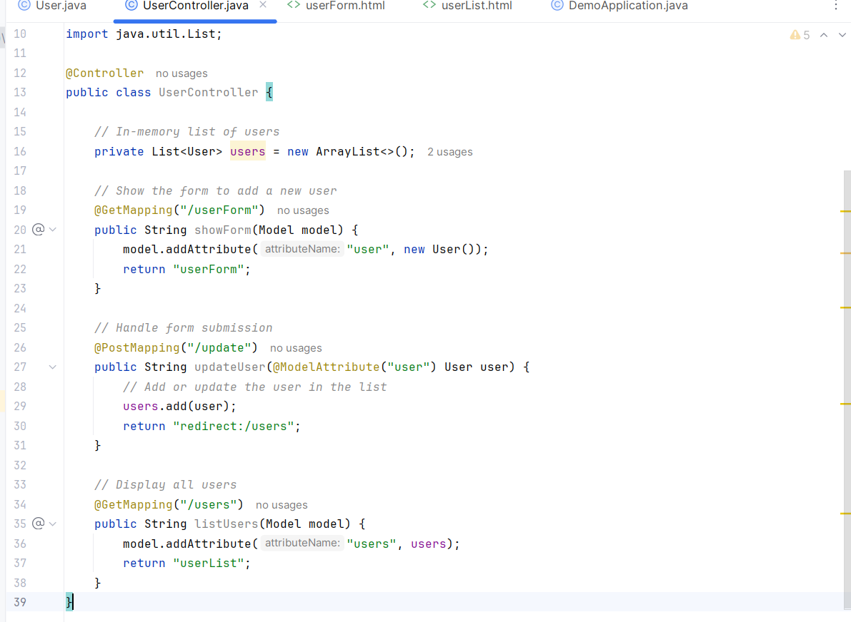

A: Incorrect. @RequestBody is used for JSON.
For normal HTML form submissions, spring binds directly to the User object.

B: Correct. @ModelAttribute ensures Spring binds form fields correctly to the User object. Without it, the model may not be populated.

C: Incorrect.redirect:/users is correct for post-redirect-get pattern.
Changing it cannot be solved the issue.

D: Incorrect. ResponseEntity is used in REST APIs to return HTTP responses. For a form submission that updates data and redirects, returning String (view name or redirect) is correct.

Q12.
Answer is C.

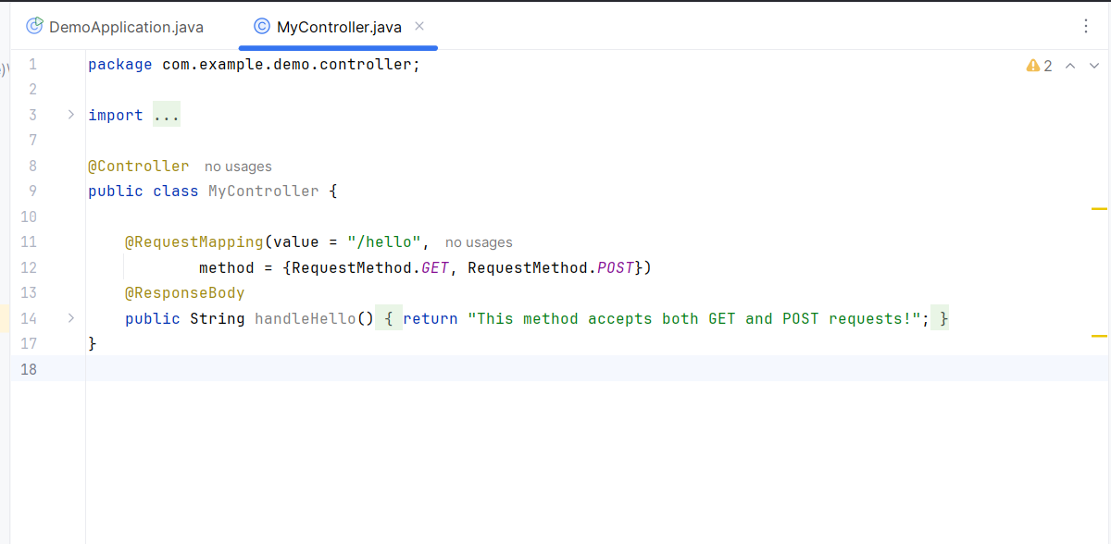

A: Incorrect. This annotation is only for GET requests.

B: Incorrect. This annotation is only for POST requests.

C: Correct. @RequestMapping is the general-purpose annotation that can handle multiple HTTP methods. the controller method accepts both GET and POST.

D: There is no such annotation in Spring MVC.

Q13.
Answer is C.

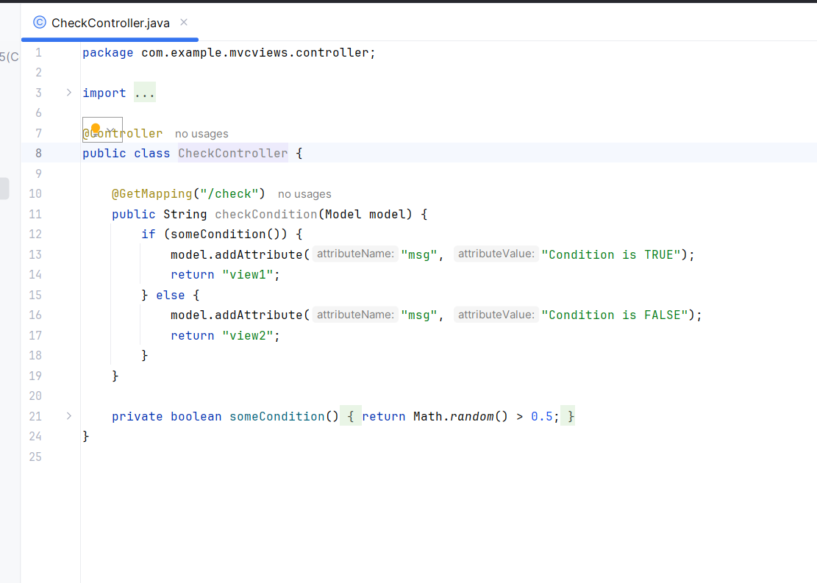

A: Incorrect. mixes String return type with ModelAndView.

B: Incorrect. returns String while method returns ModelAndView.

C: Correct. returns view names as Strings, which is the standard and recommended way in Spring MVC when using view resolvers.

D: Incorrect. uses JstlView directly.Controller should not create view implementations.

Q14.
Answer is C.

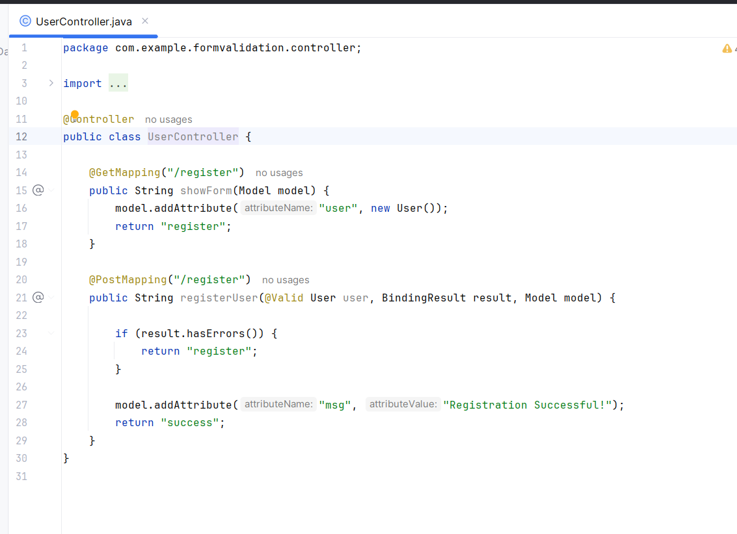

A: Incorrect. against Spring's validation framework.

B:Incorrect. JavaScript validation is good for UX but not in Spring.

C: Correct.
Add validation annotations like @NotNull, @Email, @Size to the model.
Use @Valid + BindingResult in the controller to check validation errors.
Return error messages back to the view.

D: Incorrect. Filters are meant for Logging and Authentication.

Q15.
Answer is B.

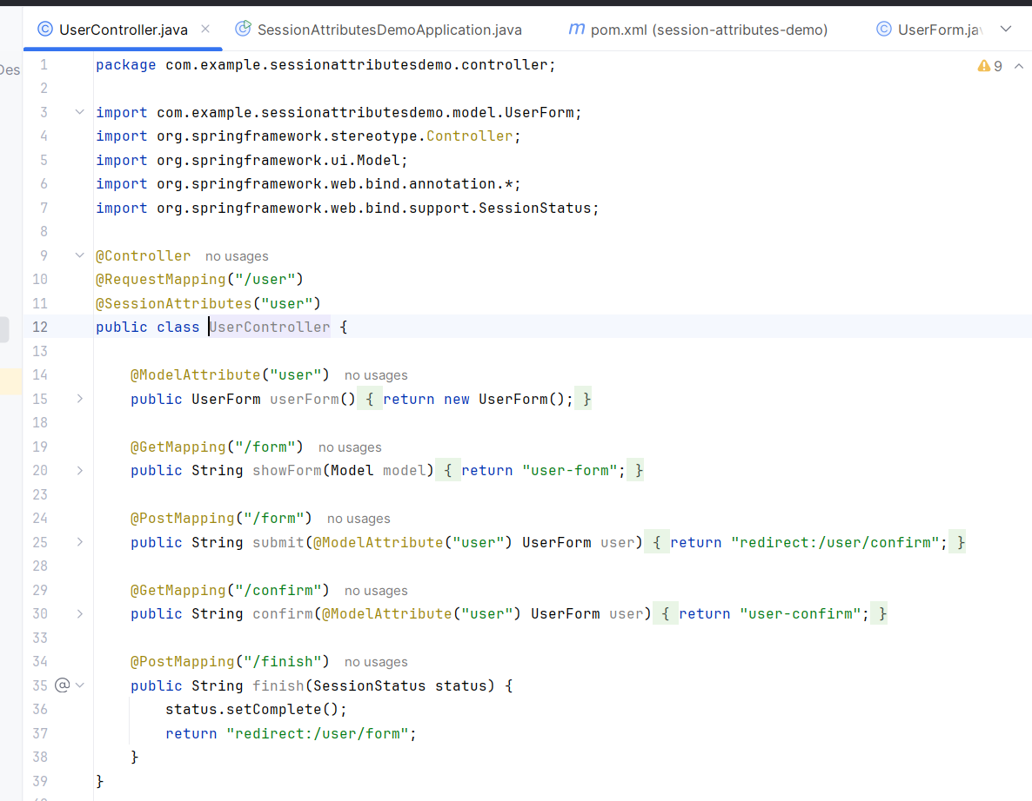

A: Incorrect. @ModelAttribute is used to bind method parameters.

B: Correct. will be stored in session and will be available in the next request.

C: Incorrect. @RequestAttribute reads attributes from the current request only.

D: Incorrect. There is no annotation called @PersistentAttributes in Spring MVC.

